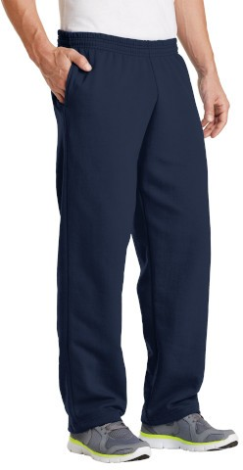
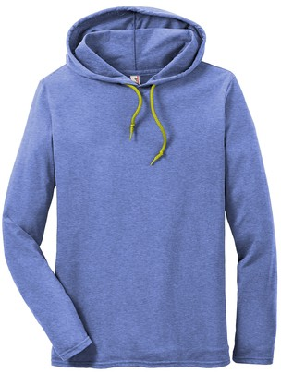
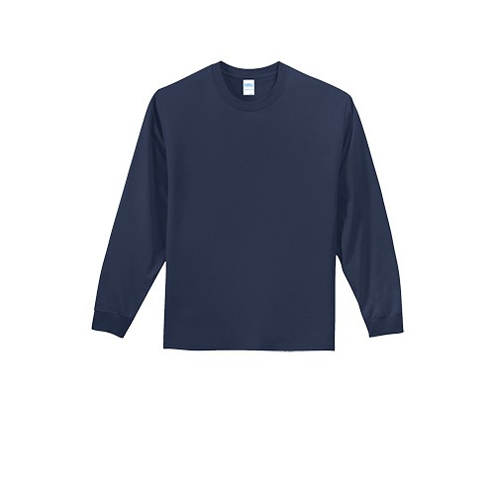
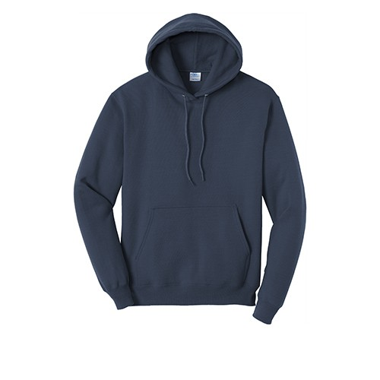

Read Mountain Swim 2021
Read Mountain Swim Team
Read Mountain Swim Team
Read Mountain Swim Team
Read Mountain Swim Team

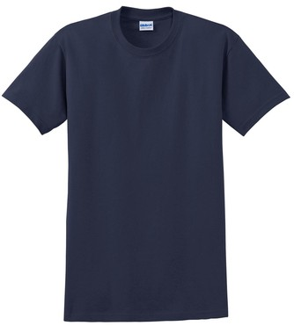
Mandatory Team Tee $10 QTY
Read Mountain Swim Team
YS YM YL

S M L XL 2XL

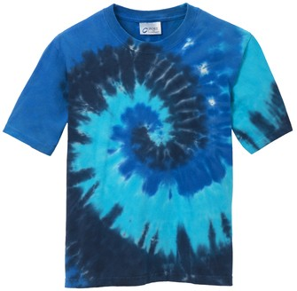

Short Sleeve Tie Dye Tee $20 QTY YS YM YL
Read Mountain Swim Team

S M L XL 2XL

Hooded Tee $26 QTY

S M L XL 2XL

White Navy Aqua
Long Sleeve Tee-$20 QTY
YS YM YL

S M L XL 2XL

Hoodie Sweatshirt-$30 QTY
YS YM YL

XS S M L XL 2XL

Heavyweight Sweatpant-$30 QTY YS YM YL
XS S M L XL 2XL

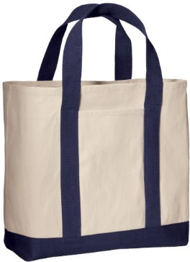

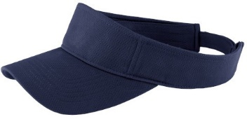

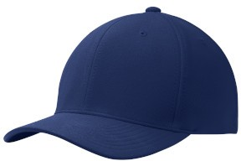

Read Mountain Swim 2021
Read Mountain Swim Team

Tote $20 QTY

Ea

Dimensions: 14"h x 14.5"w x 5.5"d

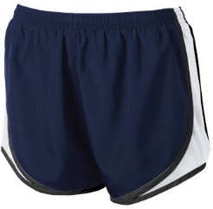

Ladies short-$25 QTY
Read Mountain Swim Team

XS S M L XL 2XL

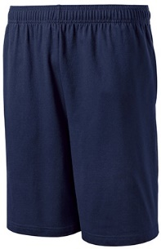

Men’s short-$25 QTY
Read Mountain Swim Team

XS S M L XL 2XL

White Navy
Visor-$20 QTY

Ea

Cap-$20 QTY

Ea

Name: TOTAL:

